Matfield Green – the most beautiful Village Green in Kent!
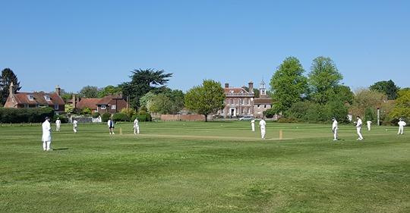
…a plea for considerate use

Parking – Cars only please
The parking area has been re-laid and extended by the Parish Council, claiming £15k from Section 106 funding being held by the Borough Council. Signs have been erected to deter large vehicles, it is not meant for lorries etc., in wet weather the surface could become damaged. Larger vehicles will be politely asked to move.

Dogs – Watch your dogs and pick up after them please
The Green is common land, open for all to use and somewhere where you can sit in peaceful surroundings. Dogs are permitted off lead however this can mean that you can’t see when they leave messages on the grass, we all know the health hazards. Please be vigilant to this, croquet, cricket and other users deserve the best environment to enjoy the whole of the Green. Dog waste bags can be put in the litter bins.

Fishing – Children of the Parish only please
Fishing in Matfield pond is open to children of the parish only. No licence is charged and fishing is permitted to encourage outdoor pursuits and an appreciation of the beautiful pond and surroundings. Fish, if caught, should be returned alive to the pond.

Litter – No meals for the foxes and birds please
The Parish Council pays for the litter bins to be emptied, please ensure that all litter is placed in the bins provided. Inevitably animals will consider this a meal table but it would be appreciated if food waste could be to a minimum, and that nappies are not placed in bins if possible.

